Assignment 16.1

Using Distributed cache join the two datasets and find out the number of temperature variations in each country using mapreduce.

Building.csv – BuildingID, BuildingMgr, BuildingAge, HVACproduct,Country

HVAC.csv – Date, Time, TargetTemp, ActualTemp, System, SystemAge, BuildingID

Driver class:

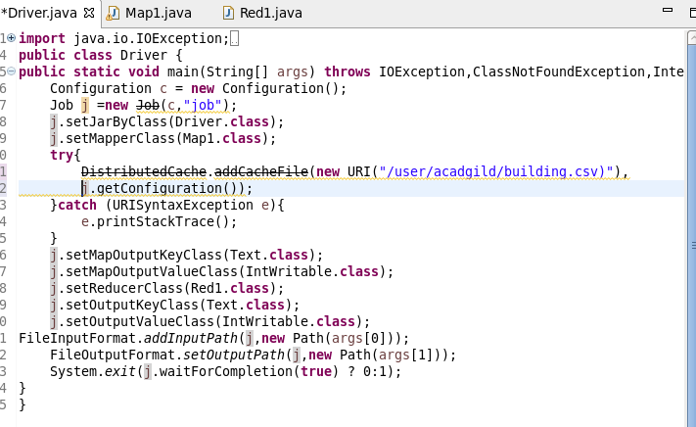

Mapper Class:



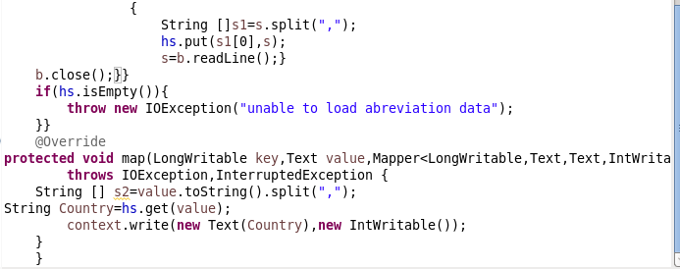

Reducer class:



Output:

